**2100090166**

**J.KASAIAH**

**.NET PROGRAMS**

**HOME ASSIGNMENT-01**

1. **Celsius to Fahrenheit Conversion.**  **Sol:**

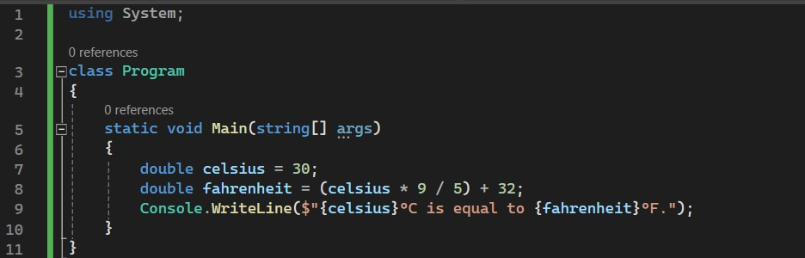

**OUTPUT:**

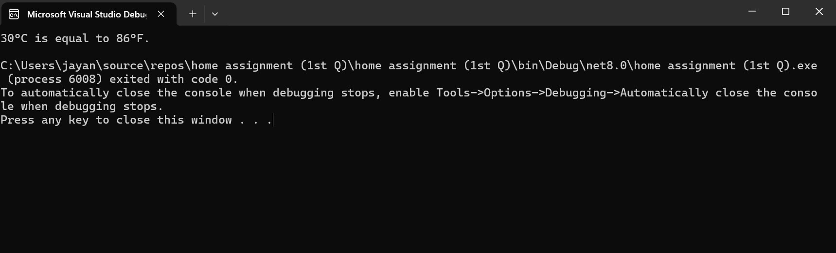

1. **Sum of Natural Numbers.**

**Sol:**

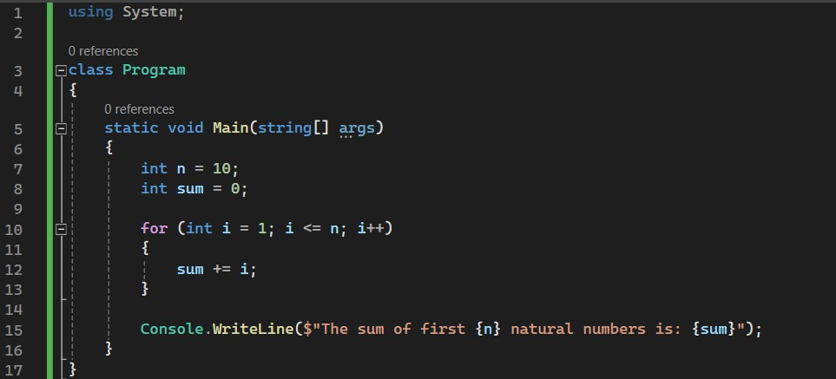

OUTPUT:

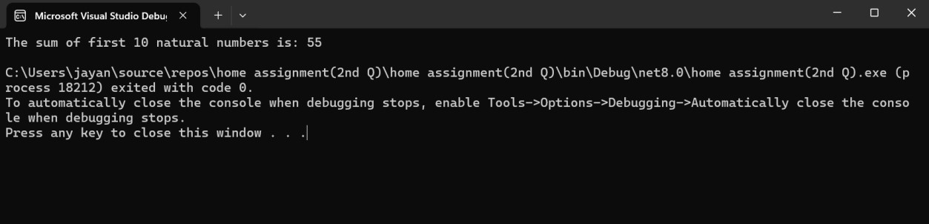

1. **Swapping of two-numbers.**

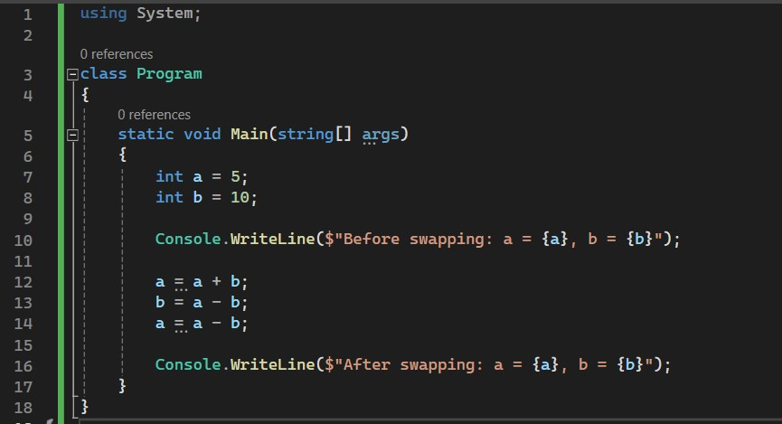

**OUTPUT:**

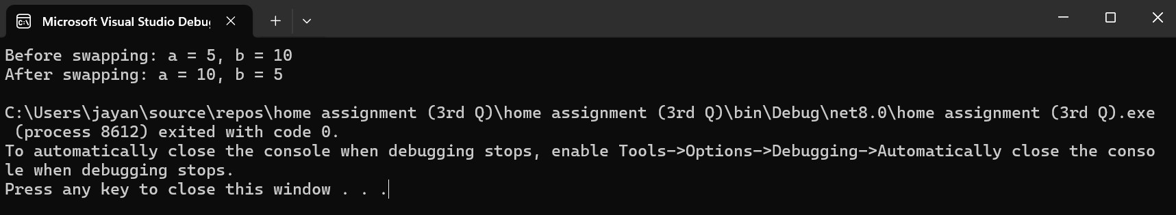

1. **Armstrong Numbers within Range .**

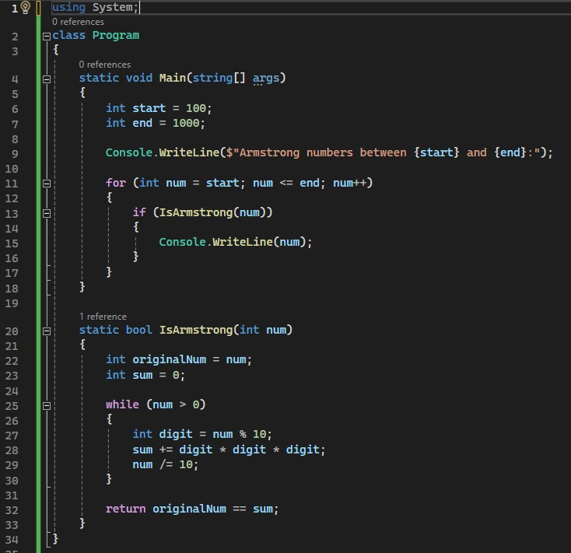

**OUTPUT:**

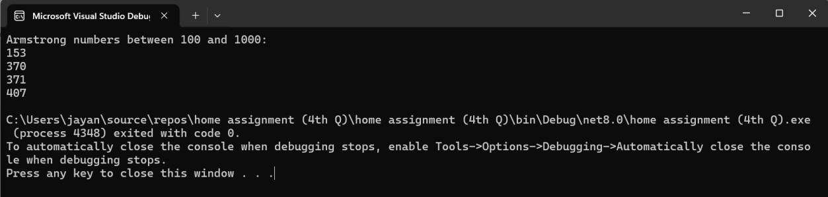

**5.Fibonacci series .**

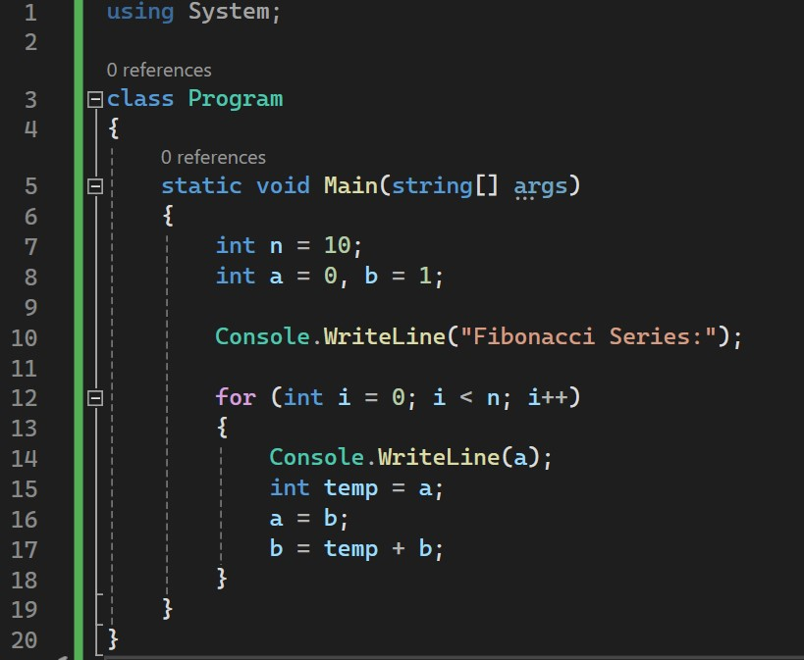

**OUTPUT:**

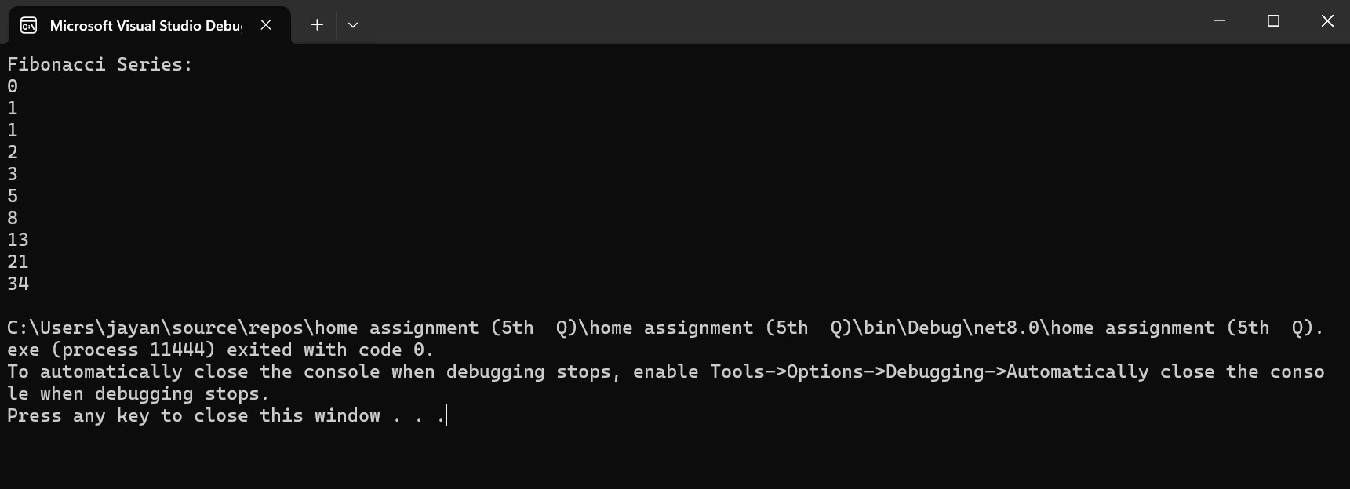

1. **Factorial with and without recursion.**

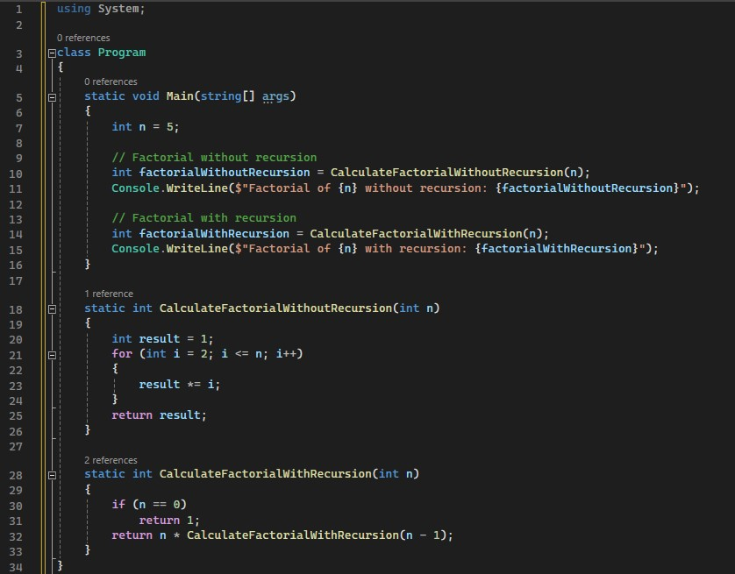

**OUTPUT:**

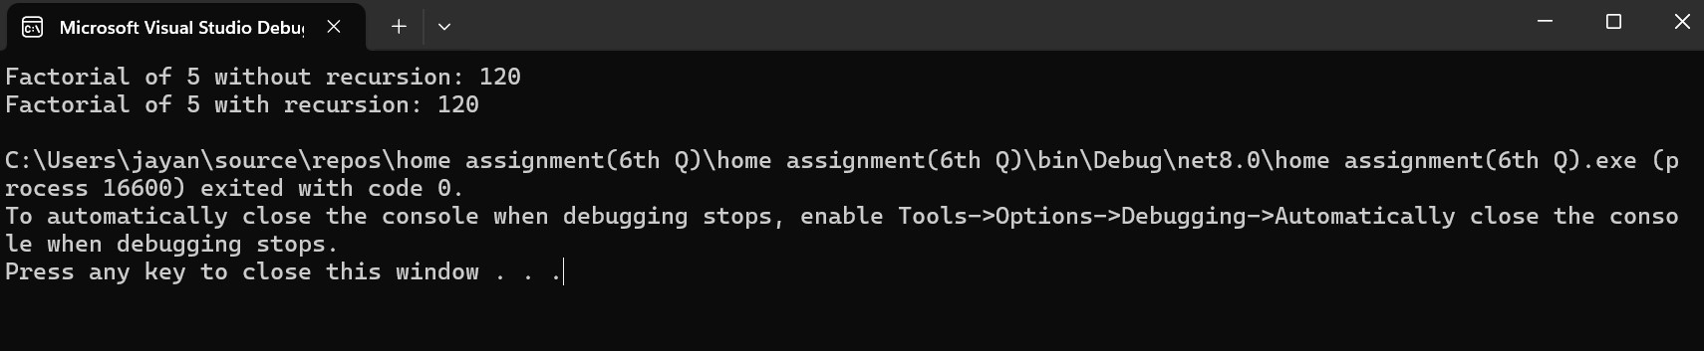

1. **Sum of digits of a given N**

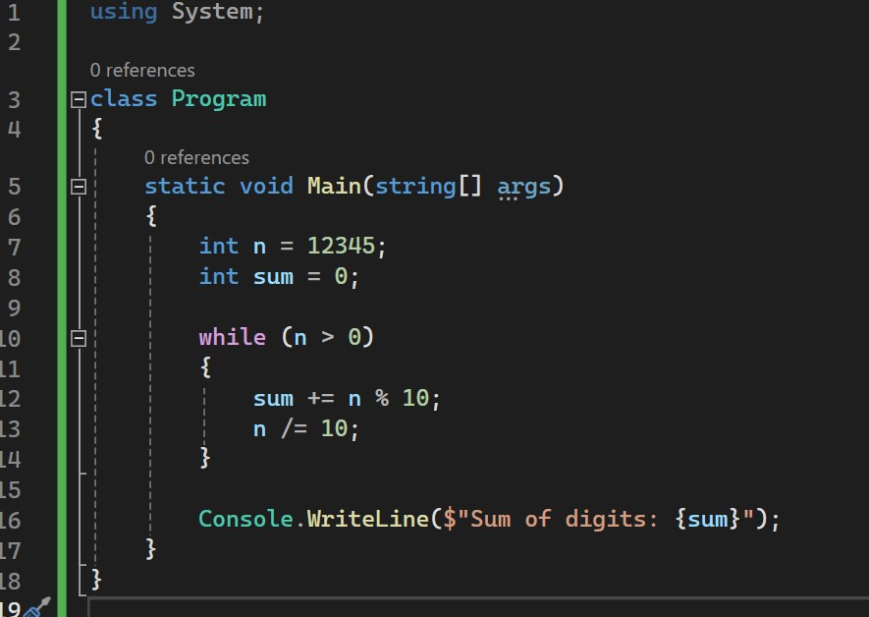

**OUTPUT**

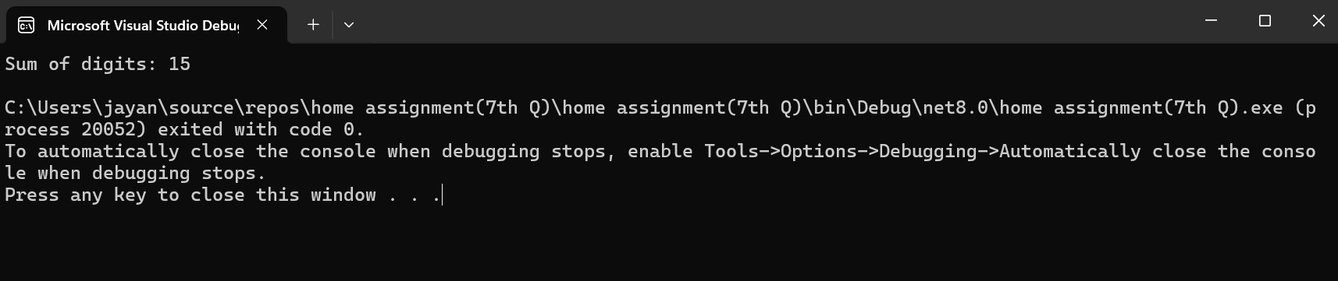

1. **Factors of N**

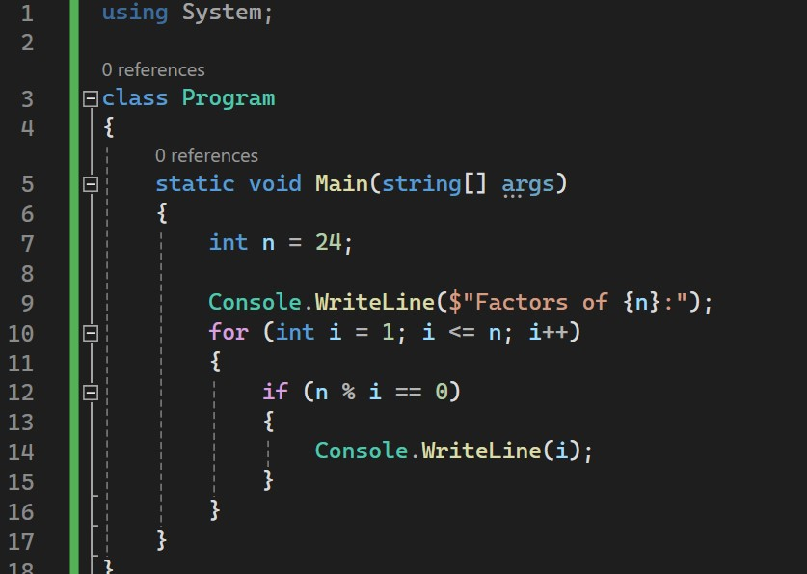

**OUTPUT:**

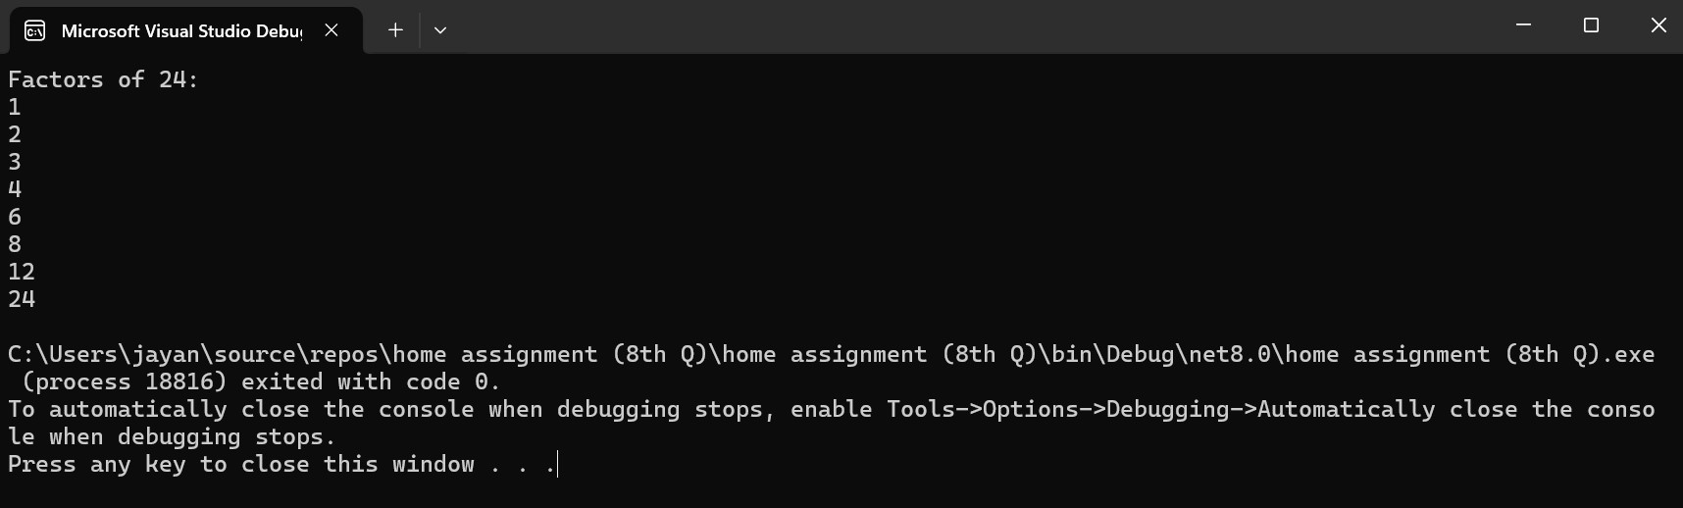

**9.Prime or Not**

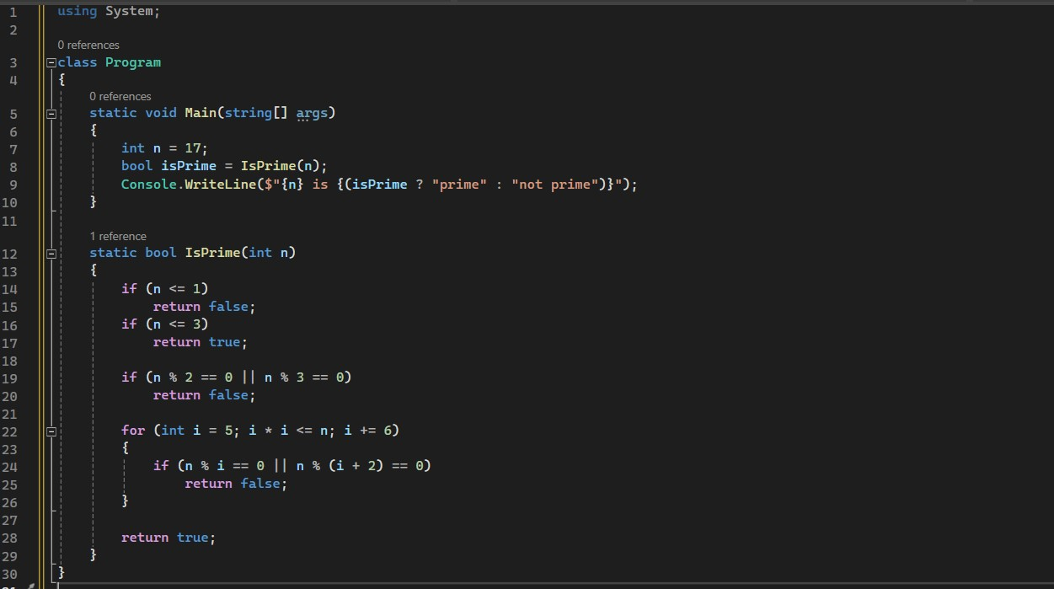

**OUTPUT:**

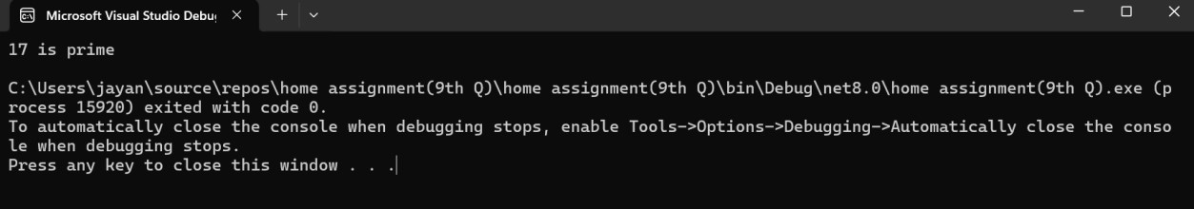

**10.palindrome or Not**

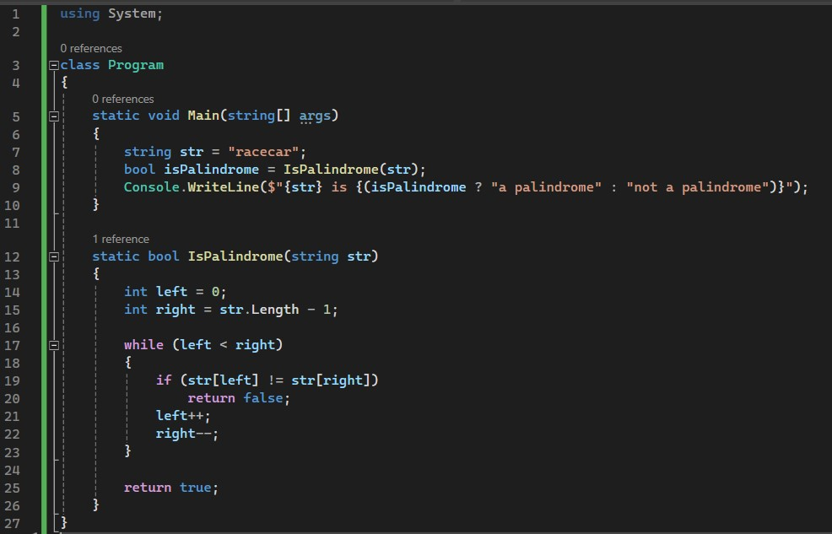

**OUTPUT:**

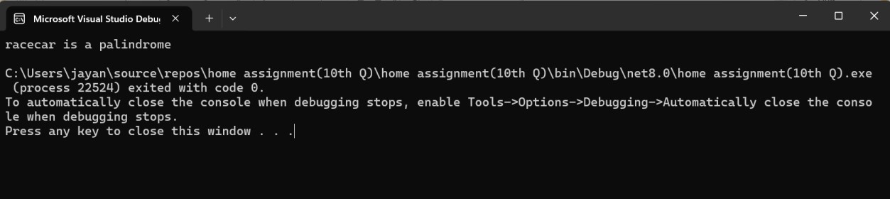

**11.Reverse of a N:**

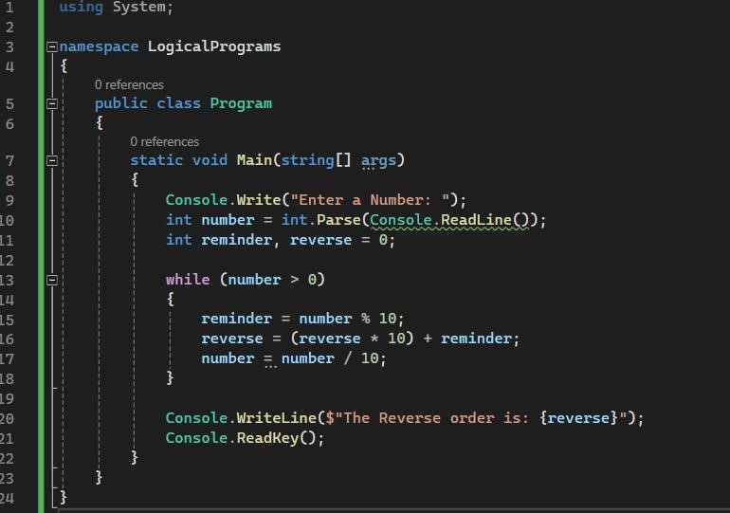

**OUTPUT:**

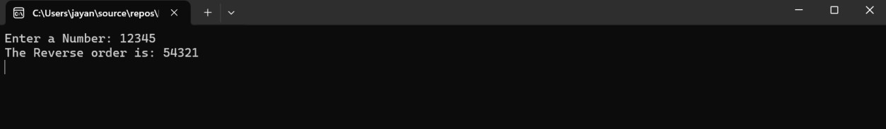

**12.Leap year or Not**

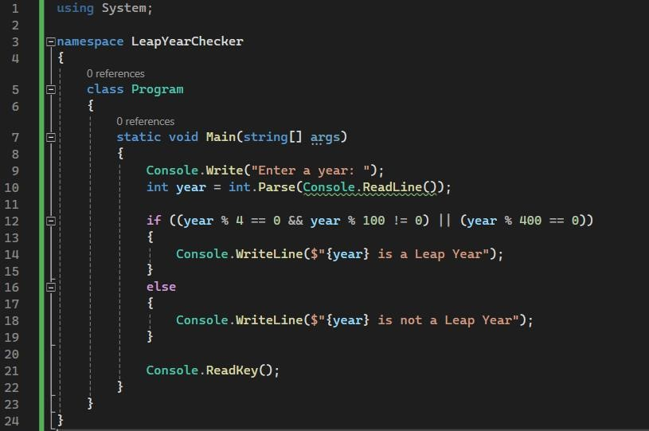

**OUTPUT:**

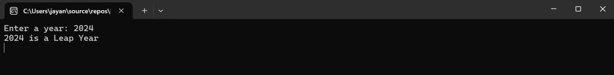

**13.Ordering of Array elements:**

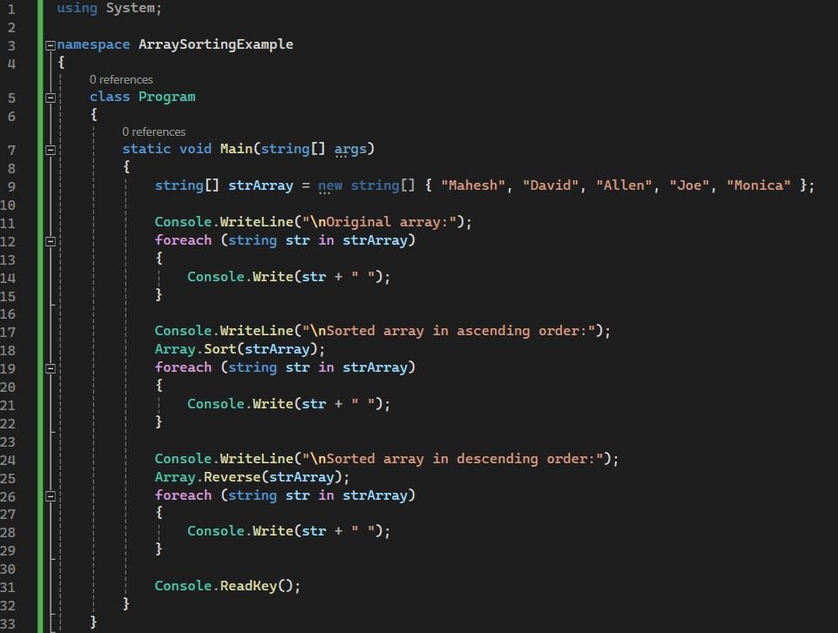

**OUTPUT:**

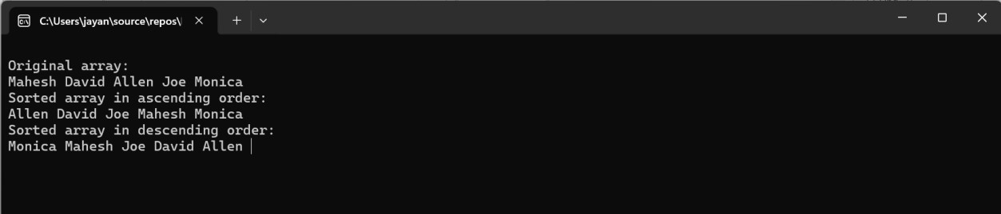

**14. String reverse:**

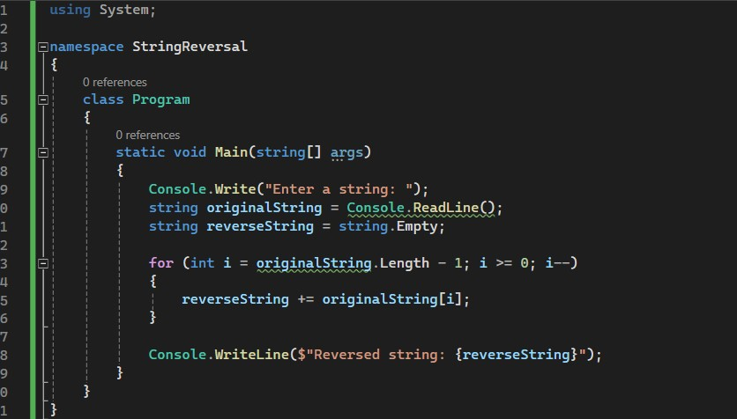

**OUTPUT:**

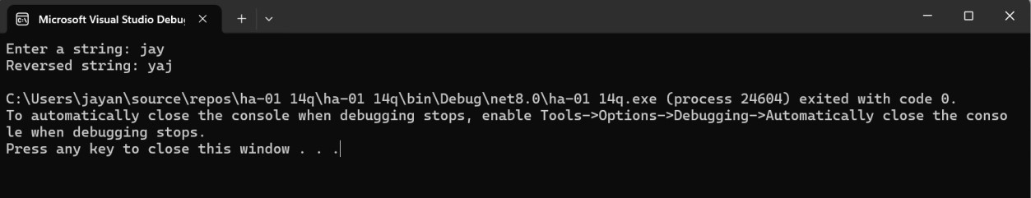

**15.String palindrome or Not:**

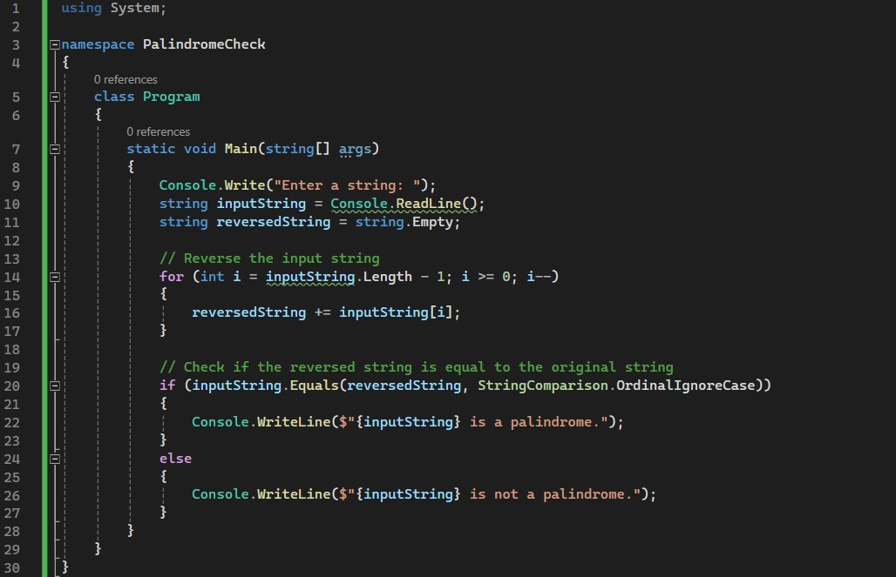

**OUTPUT:**

